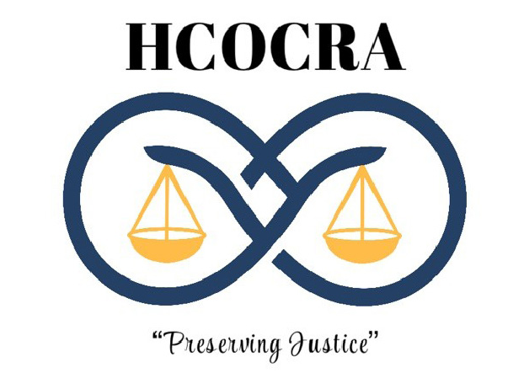

Krista Hall (Past President) Stephanie Wells (President) Hipolita Lopez (Vice-President)
Julia Rangel (Treasurer) Laurie Buchanan (Secretary) Karen Bauer (Director 1)
Kevin Bruzewski (Director 2) Sue Perry Scott (Director 3) Amanda Fazio (Director 4)
Donna King (Director 5) Mark Miller (Director 6) Deanne Bridwell (Director 7)

- Welcome and Call to Order, Stephanie Wells, President – Time: _____________________
- Role Call: Laurie Buchanan, Secretary __________________________________________
- Treasurer’s Report: Julia Rangel, Treasurer & Membership Committee Chair: __________
(Update on bank balance, past & upcoming expenses, and membership.)

- TABLED BUSINESS: Approval of Minutes – 11-19-21, 12-7-21, 1-13-22, 1-27-22 –
Laurie Buchanan, Secretary____________________________________________________

- NEW BUSINESS:
- HCOCRA Budget – Mark Miller: _____________________________________________
- Savings Account – Julia Rangel - ____________________________________________
- Pauper’s Oath Rates – Mark Miller/Stephanie Wells _____________________________
- Committee Reports – Krista Hall – Recruit / Student ____________________________
Karen Bauer – Bylaws ___________________________________
Mark Miller – Oversight __________________________________
Stephanie Wells – Website _______________________________
- Seminar Update – Stephanie Wells - __________________________________________
- Meeting with Richard Woods – Stephanie Wells - _______________________________
_________________________________________________________________________

ADDITIONAL COMMENTS / BUSINESS:

MOTION FOR ADJOURNMENT: ___________________________________________________________
2ND: __________________________________________________________________________________
TIME OF ADJOURNMENT: _______________________________________________________________

OVERSIGHT COMMITTEE – Mark Miller (Chair) NEWSLETTER & E-MAIL COMMITTEE – Laurie Buchanan
(Chair)
Carolyn Coronado Stephanie Wells
Amanda Fazio
Hipolita Lopez
Laura Tello
Stephanie Wells
Krista Hall

FINANCE/MEMBERSHIP – Julia Rangel (Chair) LEGISLATIVE COMMITTEE – Hipolita Lopez (Chair)

Jill Hamby Carolyn Coronado
Tina White Donna King
Kim Weidenheft Lettie Witter
Hipolita Lopez Krista Hall
Sue Perry Scott

BYLAWS COMMITTEE – Karen Bauer (Chair) SCHOLARSHIP & RECRUITMENT COMMITTEE - Tiffani June-Yeats
(Chair)
Carolyn Coronado Pam Coder
Deanna Bridwell Edhi Sepulveda
Stephanie Wells Gail Rolen
Laura Tello

SEMINARS & TRAINING COMMITTEE – Stephanie Wells BENEVOLENCE COMMITTEE - Sheryl Stapp (Chair)
(Chair)

Cynthia Grijalva Hipolita Lopez
Peggy Hershelman
Kathleen Keese
Amanda Fazio
Kevin Bruzewski
Donna King

WEBSITE COMMITTEE – Stephanie Wells (Chair) NOMINATING COMMITTEE – Krista Hall (Chair)

Ramona Gonzales ALL BOARD MEMBERS
Julia Rangel
(Bob Cissell can train 1 or 2 people to update
Website.)

